**Car Grooming Sales Data Analysis**

**Groomer & Co. Sales Dashboard** by Hot Wei Bin

**Team Details**

* **Team Name**: Hot Wei Bin
* **Members**:
  + **Ho Wei Bin [Presenter] (**[2202561C@student.tp.edu.sg](mailto:2202561C@student.tp.edu.sg))
  + Javen Lai Le Yu ([2202934b@student.tp.edu.sg](mailto:2202934b@student.tp.edu.sg))
  + Muhammad Danny Bin Alfie Johari ([2201245D@student.tp.edu.sg](mailto:2201245D@student.tp.edu.sg))

**Project Context**

This dashboard has been developed to analyze the sales trends and patterns of Groomer & Co., offering a comprehensive overview of business performance. It provides insights into the status of the company, potential growth opportunities, key sales drivers, and can be used to identify potential risks or areas of concern.

**Dashboard**

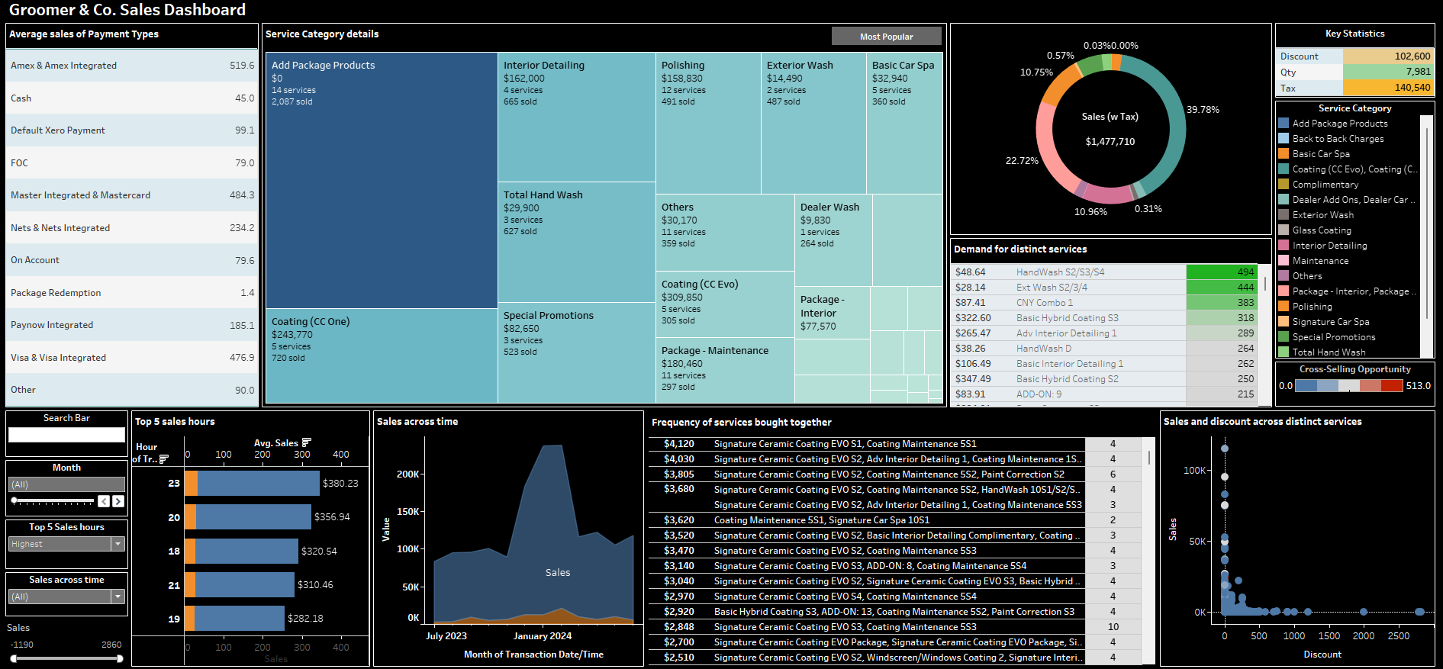

**Background of Dataset**

This dashboard is developed using Groomer & Co.'s sales data from 1 July 2023 to 31 June 2024. Utilizing the 11 given columns, we engineered 5 new features and a separate dataset that enables cross-selling analysis, unionizing the data using the order number column and service description column.

**Features Engineered:**

|  |  |
| --- | --- |
| **Column** | **Description** |
| Discount | Inversed Adjustment column into a widely known business term.  Since total sales = Unit Price x Quantity – Adjustment, Adjustment is interpreted as the discount given to customers. |
| Sales | Total revenue collected from providing services.  Calculation: Sales without Tax + Tax |
| Generic payment type | Extract the name of the Payment Type by removing ‘,’ and all the details after it. |
| Generic payment type (group) | Cluster Generic payment types into main payment types like Paynow. For analyzing overview performance of each payment type customers + ensure payment type is easily recognizable by dashboard user. |
| Service category (group) | Cluster Service Description into a group for overview analysis of each type of service. |

**Dataset of Cross-Selling Analysis**

Identifies orders with (> 1) service descriptions as they could be cross-selling opportunities.

*Order number represents the invoice for a customer’s purchase.*

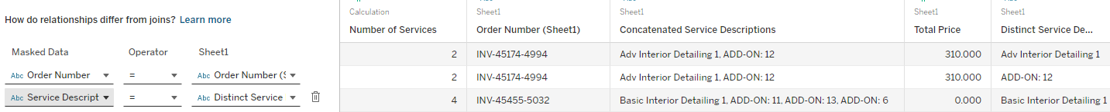

|  |  |
| --- | --- |
| **Column** | **Description** |
| Number of services | Count of Service Description concatenated to form Concatenated Service Description. |
| Concatenated Service Description | Service Descriptions with the same Order Number are concatenated together. We assume that having the same Order Number represents the services that were bought together. |
| Total Price | Price paid for the service provided. |

**Insights**

|  |  |  |
| --- | --- | --- |
| **No.** | **Insights** | **Illustration** |
| 1.1 | Carwash promotion in September |  |
| 1.2 | Ext Wash S2/3/4 is frequently purchased with Interior Detailing; bundling them could encourage customers to use both services. |  |
| 1.3 | Sales **increased** for:  Ext Wash S2/3/4 + Adv Interior Detailing 1 (constant price)  But **declined** for:  Ext Wash S2/3/4 + Adv Interior Detailing 2 (price increased by $88)  Conclusion: price hike contributed to the sales drop after December. | December 2023:    February 2024: |
| 1.4 | Raising prices on basic services can encourage upselling by making premium options seem more appealing. | December 2023:    February 2024: |
| 2 | Negative sales in March at 7 PM indicate significant impairment losses.  The business should investigate March operations since there are no sales.  Highest losses occurred on Saturdays. | *Red annotations are analytical interactions used* |
| 3.1 | Dec, Jan, and Feb grossed the highest sales. CNY has the highest demand but only accounts for 16% of sales; Coating still brought the most sales (39%). |  |
| 3.2 | Consider bundling add-ons with seasonal deals. |  |
| 4 | For special occasions, lower prices lead to higher demand; Design cost-effective promotions below $100. |  |
| 5.1 | Coating is the most popular service (~40% of total sales) and 53% ((318+250)/1079) are Basic Hybrid Coating. |  |
| 5.2 | Hybrid Coating is frequently paired with other services, 24% of which are Paint Correction (53+85/568).  Bundling Coating with underperforming services could be effective, as customers often combine coating with various services. |  |
| 5.3 | Top 10 low-demand services:    Ceramic Coating services are highly cross-sellable in poor-performing categories as it is often bought with other services. |  |
| 6 | Top credit card networks have the highest average sales. Design campaigns to encourage spending for other payments: |  |
| 7 | Discounts inversely proportionate to sales.  Frequent discounts might cause discount fatigue, making regular prices seem inflated or cheaper services appear inferior, resulting in reduced sales. |  |
| 8 | Since customers mostly prefer CC One or CC EVO for coating, bundle CC36 as a cross-selling package alongside corrective maintenance services since its commonly purchased with CC One or CC EVO to encourage customers to try out CC36. |  |

**End of Report**